**Network Technologies IT51**

**MCA-FY**

**Chapter-01**

**Basics of Computer Networking: What is, Advantages, Components,Uses**

1.1. Internet basics and network components. [Transmission Media-Guided, Unguided, Network Devices]

1.2. Various types of Networks (only overview)

1.2.1. Connection Oriented N/Ws Vs Connectionless N/Ws,

1.2.2. Ethernet- Ethernet standards ZigBee, WiFi, Access Technique -CSMA-CD, Negotiation technique Overview

1.2.3. Wireless Network

1.3 Unified Communication –VOIP

Extra Reading:

Switching Techniques, CSMA/CA, CSMA/CD, Unified Communication

**What is a Computer Network?**

A computer network is a group of two or more interconnected computer systems. You can establish a network connection using either cable or wireless media.

Every network involves hardware and software that connects computers and tools.

**Advantages of a Computer Network**

Here are the fundamental benefits/pros of using Computer Networking:

Helps you to connect with multiple computers together to send and receive information when accessing the network.

Helps you to share printers, scanners, and email.

Helps you to share information at very fast speed

Electronic communication is more efficient and less expensive than without the network.

**Computer Network Components**

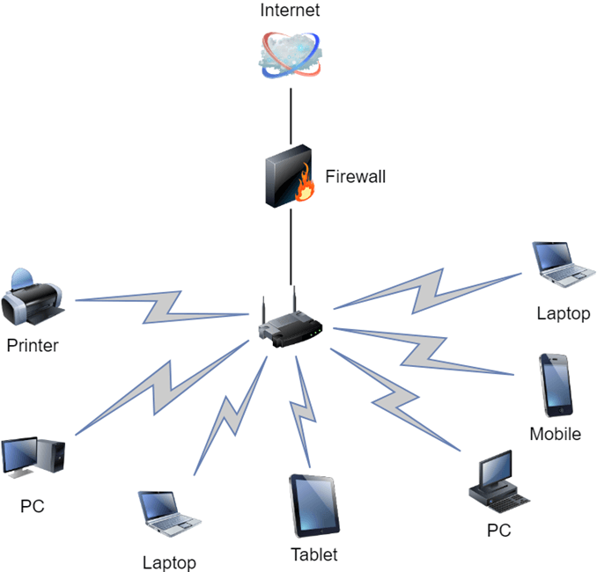

**Here are essential computer network components:**

**Switches**

Switches work as a controller which connects computers, printers, and other hardware devices to a network in a campus or a building.

It allows devices on your network to communicate with each other, as well as with other networks. It helps you to share resources and reduce the costing of any organization.

**Routers**

Routers help you to connect with multiple networks. It enables you to share a single internet connection with multiple devices and saves money. This networking component acts as a dispatcher, which allows you to analyze data sent across a network. It automatically selects the best route for data to travel and send it on its way.

**Servers:**

Servers are computers that hold shared programs, files, and the network operating system. Servers allow access to network resources to all the users of the network.

**Clients:**

Clients are computer devices which access and uses the network as well as shares network resources. They are also users of the network, as they can send and receive requests from the server.

**Transmission Media:**

Transmission media is a carrier used to interconnect computers in a network, such as coaxial cable, twisted-pair wire, and optical fiber cable. It is also known as links, channels, or lines.

**Access points**

Access points allow devices to connect to the wireless network without cables. A wireless network allows you to bring new devices and provides flexible support to mobile users.

**Shared Data:**

Shared data are data which is shared between the clients such as data files, printer access programs, and email.

**Network Interface Card:**

Network Interface card sends, receives data, and controls data flow between the computer and the network.

**Local Operating System:**

A local OS which helps personal computers to access files, print to a local printer and uses one or more disk and CD drives which are located on the computer.

**Network Operating System:**

The network operating system is a program which runs on computers and servers. It allows the computers to communicate via network.

**Protocol:**

A protocol is the set of defined rules that allows two entities to communicate across the network. Some standard protocols used for this purpose are IP, TCP, UDP, FTP, etc.

**Hub:**

Hub is a device that splits network connection into multiple computers. It acts a distribution center so whenever a computer requests any information from a computer or from the network it sends the request to the hub through a cable. The hub will receive the request and transmit it to the entire network.

**LAN Cable:**

Local Area Network(LAN) cable is also called as Ethernet or data cable. It is used for connecting a device to the internet.

**OSI:**

OSI stands for Open Systems Interconnection. It is a reference model which allows you to specify standards for communications.

**Unique Identifiers of Network**

Below given are some unique network identifiers:

**Hostname:**

Every device of the network is associated with a unique device, which is called hostname.

**IP Address:**

IP (Internet Protocol) address is as a unique identifier for each device on the Internet. Length of the IP address is 32-bits. IPv6 address is 64 bits.

**DNS Server:**

DNS stands for Domain Name System. It is a server which translates URL or web addresses into their corresponding IP addresses.

**MAC Address:**

MAC (Media Access Control Address) is known as a physical address is a unique identifier of each host and is associated with the NIC (Network Interface Card). General length of MAC address is : 12-digit/ 6 bytes/ 48 bits

**Port:**

Port is a logical channel which allows network users to send or receive data to an application. Every host can have multiple applications running. Each of these applications are identified using the port number on which they are running.

**Other Important Network Components**

**ARP:**

ARP stands for Address Resolution Protocolwhich helps network users to convert the IP address into its corresponding Physical Address.

**RARP:**

Reverse Address Resolution Protocol gives an IP address of the device with given a physical address as input.

**Uses of Computer Networks**

**Here are some common application of computer networks**

Helps you to share resource such as printers

Allows you to share expensive software's and database among network participants

Provides fast and effective communication from one computer to another computer

Helps you to exchange data and information among users via a network.

**Types of Computer Networks: LAN, MAN, WAN, VPN**

**What Are the Important Types of Computer Networks?**

There are various types of computer networks available. We can categorize them according to their size as well as their purpose.

The size of a network should be expressed by the geographic area and number of computers, which are a part of their networks. It includes devices housed in a single room to millions of devices spread across the world**.**

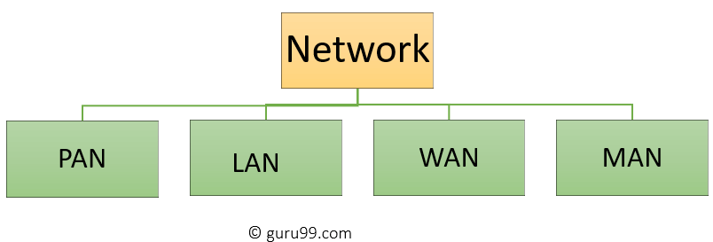

**What is PAN (Personal Area Network)?**

PAN is a computer network formed around a person. It generally consists of a computer, mobile, or personal digital assistant. PAN can be used for establishing communication among these personal devices for connecting to a digital network and the internet.

**Features of PAN**

It is mostly personal devices network equipped within a limited area.

Allows you to handle the interconnection of IT devices at the surrounding of a single user.

PAN includes mobile devices, tablet, and laptop.

It can be wirelessly connected to the internet called WPAN.

Appliances use for PAN: cordless mice, keyboards, and Bluetooth systems.

What is LAN?

Local Area Network (LAN) is a group of computer and peripheral devices which are connected in a limited area such as school, laboratory, home, and office building. It is a widely useful network for sharing resources like files, printers, games, and other application. The simplest type of LAN network is to connect computers and a printer in someone's home or office. In general, LAN will be used as one type of transmission medium.

It is a network which consists of less than 5000 interconnected devices across several buildings.

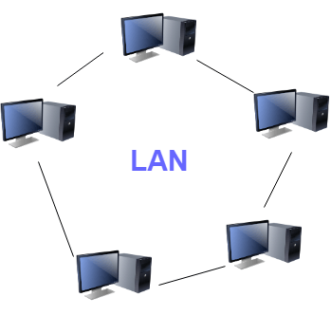

**What is WAN?**

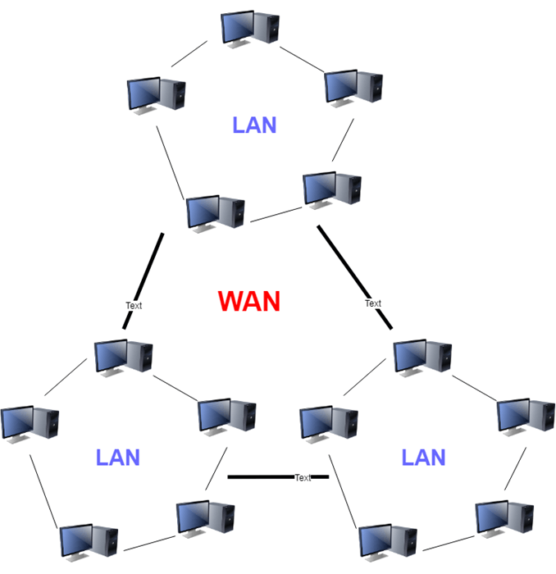

WAN (Wide Area Network) is another important computer network that which is spread across a large geographical area. WAN network system could be a connection of a LAN which connects with other LAN's using telephone lines and radio waves. It is mostly limited to an enterprise or an organization.

What is MAN?

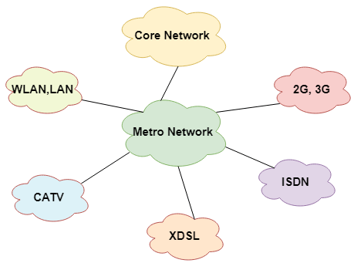

A Metropolitan Area Network or MAN is consisting of a computer network across an entire city, college campus, or a small region. This type of network is large than a LAN, which is mostly limited to a single building or site. Depending upon the type of configuration, this type of network allows you to cover an area from several miles to tens of miles.

Type of Network Topology: Bus, Ring, Star, Mesh, Tree, P2P, Hybrid

What is Topology?

Network topologies describe the methods in which all the elements of a network are mapped. The topology term refers to both the physical and logical layout of a network.

Types of Networking Topologies

Two main types of networking topologies are 1) Physical topology 2) Logical topology

Physical topology:

This type of network is an actual layout of the computer cables and other network devices

Logical topology:

Logical topology gives insight's about network's physical design.

Different types of Physical Topologies are:

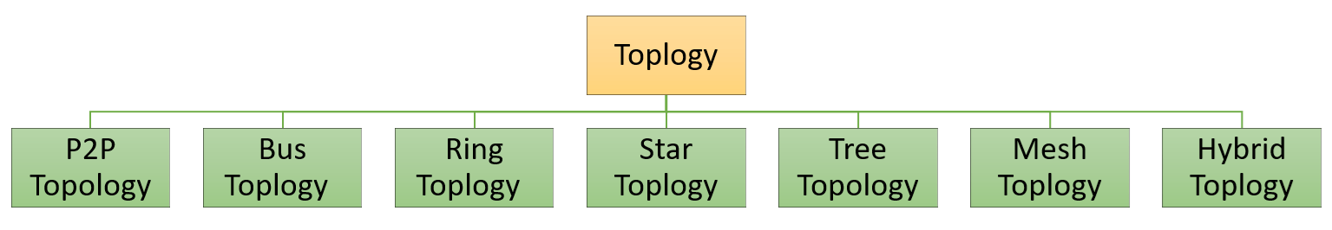

Point to Point

Point-to-point topology is the easiest of all the network topologies. In this method, the network consists of a direct link between two computers.

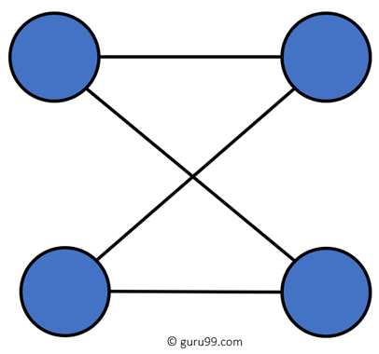

Bus topology uses a single cable which connects all the included nodes. The main cable acts as a spine for the entire network. One of the computers in the network acts as the computer server. When it has two endpoints, it is known as a linear bus topology.

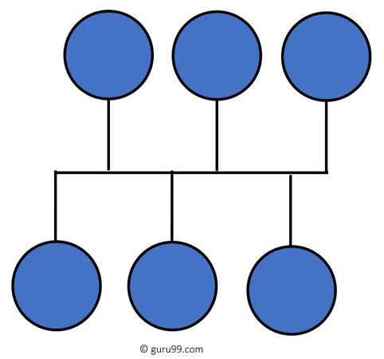

**Transmission media**

Transmission media is a communication channel that carries the information from the sender to the receiver. Data is transmitted through the electromagnetic signals. The main functionality of the transmission media is to carry the information in the form of bits through LAN(Local Area Network).

Transmission media are of two types −

Guided Transmission Medium

Unguided Transmission Medium

The following chart categorizes transmission media −

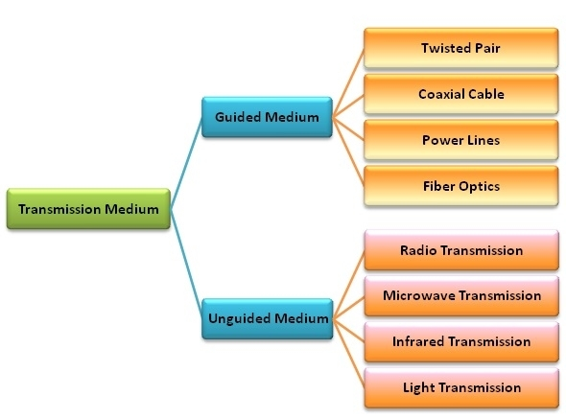

**Guided Transmission Medium**

Guided transmission media are also called bounded media or wired media. They comprise cables or wires through which data is transmitted. They are called guided since they provide a physical conduit from the sender device to the receiver device. The signal traveling through these media are bounded by the physical limits of the medium.

The most popular guided media are −

Twisted pair cable

Coaxial cable

Power lines

Fiber optics

**Unguided Transmission Medium**

Unguided transmission media are also called wireless media. They transport data in the form of electromagnetic waves that do not require any cables for transmission. These media are bounded by geographical boundaries. These type of communication is commonly referred to as wireless communications.

**Unguided signals can travel in three ways −**

Ground propagation

Sky propagation

Line – of – sight propagation

**The commonly used unguided transmissions are −**

Radio transmission

Microwave transmission

Infrared transmission

Light transmission

There are 3 major types of Guided Media:

(i) Twisted Pair Cable –

It consists of 2 separately insulated conductor wires wound about each other. Generally, several such pairs are bundled together in a protective sheath. They are the most widely used Transmission Media. Twisted Pair is of two types:

Unshielded Twisted Pair (UTP):

This type of cable has the ability to block interference and does not depend on a physical shield for this purpose. It is used for telephonic applications.

Advantages:

Least expensive

Easy to install

High-speed capacity

Susceptible to external interference

Lower capacity and performance in comparison to STP

Short distance transmission due to attenuation

Shielded Twisted Pair (STP):

This type of cable consists of a special jacket to block external interference. It is used in fast-data-rate Ethernet and in voice and data channels of telephone lines.

Advantages:

Better performance at a higher data rate in comparison to UTP

Eliminates crosstalk

Comparatively faster

Comparatively difficult to install and manufacture

More expensive

Bulky

(ii) Coaxial Cable –

It has an outer plastic covering containing 2 parallel conductors each having a separate insulated protection cover. The coaxial cable transmits information in two modes: Baseband mode(dedicated cable bandwidth) and Broadband mode(cable bandwidth is split into separate ranges). Cable TVs and analog television networks widely use Coaxial cables.

Advantages:

High Bandwidth

Better noise Immunity

Easy to install and expand

Inexpensive

Disadvantages:

Single cable failure can disrupt the entire network

(iii) Optical Fibre Cable –

It uses the concept of reflection of light through a core made up of glass or plastic. The core is surrounded by a less dense glass or plastic covering called the cladding. It is used for the transmission of large volumes of data.

The cable can be unidirectional or bidirectional. The WDM (Wavelength Division Multiplexer) supports two modes, namely unidirectional and bidirectional mode.

**Advantages:**

Increased capacity and bandwidth

Lightweight

Less signal attenuation

Immunity to electromagnetic interference

Resistance to corrosive materials

**Disadvantages:**

Difficult to install and maintain

High cost

**2. Unguided Media:**

It is also referred to as Wireless or Unbounded transmission media.No physical medium is required for the transmission of electromagnetic signals.

Features:

The signal is broadcasted through air

Less Secure

Used for larger distances

There are 3 types of Signals transmitted through unguided media:

(i) Radiowaves –

These are easy to generate and can penetrate through buildings. The sending and receiving antennas need not be aligned. Frequency Range:3KHz – 1GHz. AM and FM radios and cordless phones use Radiowaves for transmission.

Further Categorized as (i) Terrestrial and (ii) Satellite.

(ii) Microwaves –

It is a line of sight transmission i.e. the sending and receiving antennas need to be properly aligned with each other. The distance covered by the signal is directly proportional to the height of the antenna. Frequency Range:1GHz – 300GHz. These are majorly used for mobile phone communication and television distribution.

(iii) Infrared –

Infrared waves are used for very short distance communication. They cannot penetrate through obstacles. This prevents interference between systems. Frequency Range:300GHz – 400THz. It is used in TV remotes, wireless mouse, keyboard, printer, etc.

**P2P** The network consists of a direct link between two computers



**Bus** Uses a single cable which connects all the included nodes



**Ring** Every device has exactly two neighboring devices for communication purpose

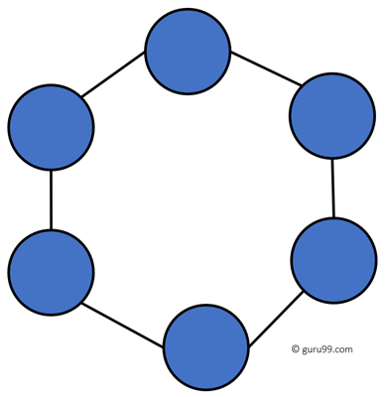

The most common access method of the ring topology is token passing.

Token passing: It is a network access method in which token is passed from one node to another node.

**Token**: It is a frame that circulates around the network.

**Working of Token passing**

A token moves around the network, and it is passed from computer to computer until it reaches the destination.

The sender modifies the token by putting the address along with the data.

The data is passed from one device to another device until the destination address matches. Once the token received by the destination device, then it sends the acknowledgment to the sender.

In a ring topology, a token is used as a carrier.

**Star** All the computers connect with the help of a hub.

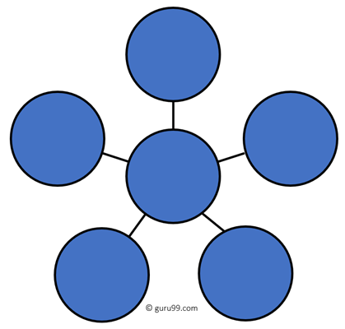

**Mesh** The mesh topology has a unique network design in which each computer on the network connects to every other.

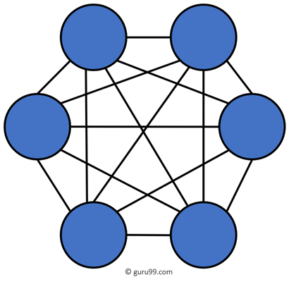

**Tree Tree topologies** have a root node, and all other nodes are connected which forming a hierarchy.

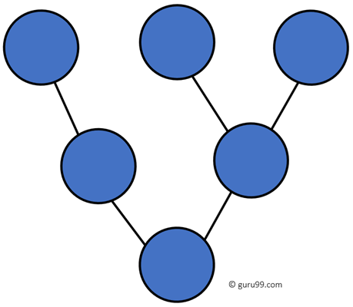

**Hybrid Topology** Hybrid topology combines two or more topologies

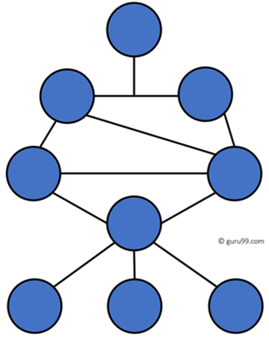

**What is an Analog Signal?**

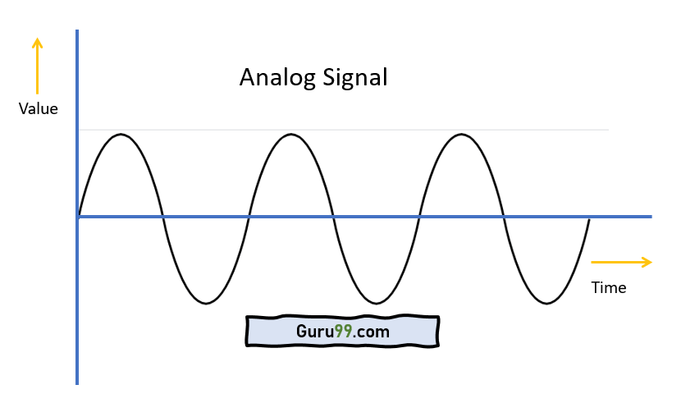

**Analog signal** is a continuous signal in which one time-varying quantity represents another time-based variable. These kind of signals works with physical values and natural phenomena such as earthquake, frequency, volcano, speed of wind, weight, lighting, etc.

**What is a Digital Signal?**

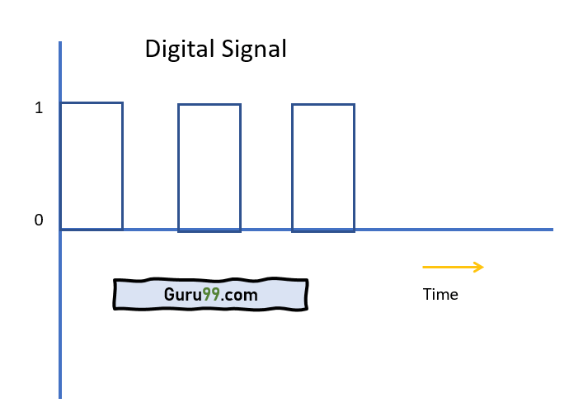

**A digital signal** is a signal that is used to represent data as a sequence of separate values at any point in time. It can only take on one of a fixed number of values. This type of signal represents a real number within a constant range of values.

**Transmission mode** means transferring of data between two devices. It is also known as communication mode. Buses and networks are designed to allow communication to occur between individual devices that are interconnected. There are three types of transmission mode:-

Simplex Mode

Half-Duplex Mode

Full-Duplex Mode

Simplex Mode

**In Simplex mode**, the communication is unidirectional, as on a one-way street. Only one of the two devices on a link can transmit, the other can only receive. The simplex mode can use the entire capacity of the channel to send data in one direction.

**Example:** Keyboard and traditional monitors. The keyboard can only introduce input, the monitor can only give the output.



**Half-Duplex Mode**

In half-duplex mode, each station can both transmit and receive, but not at the same time. When one device is sending, the other can only receive, and vice versa. The half-duplex mode is used in cases where there is no need for communication in both direction at the same time. The entire capacity of the channel can be utilized for each direction.

**Example:** Walkie- talkie in which message is sent one at a time and messages are sent in both the directions.

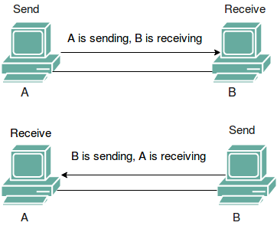

**Full-Duplex Mode**

In full-duplex mode, both stations can transmit and receive simultaneously. In full_duplex mode, signals going in one direction share the capacity of the link with signals going in other direction, this sharing can occur in two ways:

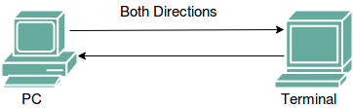

Example of the Full-duplex mode is a telephone network.

**Types of Networking-**

**MCQ**

1. The _______ is the physical path over which a message travels.

A. Protocol

B. Medium

C. Signal

D. All the above

2. Ethernet uses a ------------ Physical address that is imprinted in NIC Card is

A.32 Bit

B. 64 Bit

C. 6 Bit

D. None of the above

3. Transmission media are usually categorized as -------

A.Fixed or unfixed

B.Guided or unguided

C. determinate or indeterminate

D. Metallic or nonmetallic

4. Signals can be ________

A. analog

B. digital

C. either (a) or (b)

D. None of the above.

5. What do you call a communicaiton system in which data cannot be sent in both direction at the same time?

A. Synchronous

B. Half Duplex

C. Asynchronous

D. Full Duplex

6. Physical or logical arrangement of network is __________  
a) Topology  
b) Routing  
c) Networking  
d) Control

7. Which network topology requires a central controller or hub?  
a) Star  
b) Mesh  
c) Ring  
d) Bus

8 Data communication system spanning states, countries, or the whole world is ________  
a) LAN  
b) WAN  
c) MAN  
d) PAN

9 _______ is a set of rules that governs data communication.

A. forum

B.protocol

C. standard

D.none of the above

10. _______ connection provides a dedicated link between two devices.

A. point-to-point

B.multipoint

C.primary

D. secondary

**Connection Oriented and Connectionless Networks**

connection establishment between two or more than two devices. These type of services are offered by network layer.

Connection-oriented service is related to the telephone system. It includes the connection establishment and connection termination. In connection-oriented service, Handshake method is used to establish the connection between sender and receiver.

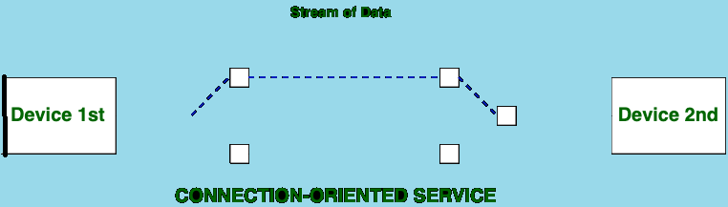

Connection-less service is related to the postal system. It does not include any connection establishment and connection termination. Connection-less Service does not give the guarantee of reliability. In this, Packets do not follow same path to reach destination.

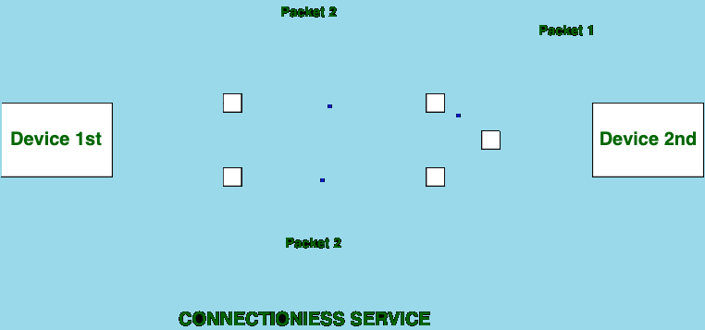

**Difference between Connection-oriented and Connection-less Services:**

**Connection-oriented Service Connection-less Service**

1. Connection-oriented service is related to the telephone system. Connection-less service is related to the postal system.

2. Connection-oriented service is preferred by long and steady communication. Connection-less Service is preferred by bursty communication.

3. Connection-oriented Service is necessary. Connection-less Service is not compulsory.

4. Connection-oriented Service is feasible. Connection-less Service is not feasible.

5. In connection-oriented Service, Congestion is not possible. In connection-less Service, Congestion is possible.

6. Connection-oriented Service gives the guarantee of reliability. Connection-less Service does not give the guarantee of reliability.

7. In connection-oriented Service, Packets follow the same route. In connection-less Service, Packets do not follow the same route.

8. Connection-oriented Services requires a bandwidth of high range. Connection-less Service requires a bandwidth of low range.

**Types of LAN Technology**

Ethernet

Ethernet is the most popular physical layer LAN technology .

An ideal networking technology for most computer users today.

A standard Ethernet network can transmit data at a rate up to 10 Megabits per second (10 Mbps).

Ethernet is popular because it strikes a good balance between speed, cost and ease of installation.

**Standards:-**

**Name IEEE Standard Data Rate**

Ethernet 802.3 10 Mbps 100 meters

Fast Ethernet/ 100Base-T 802.3u 100 Mbps 100 meters

2000 meters

Gigabit Ethernet/ GigE 802.3z 1000 Mbps 100 meters

275/550 meters

550/5000 meters

10 Gigabit Ethernet IEEE 802.3ae 10 Gbps 300 meters

300m MMF/ 10km SMF

10km/40km

300m/10km/40km

The Institute for Electrical and Electronic Engineers developed an Ethernet standard known as IEEE Standard 802.3. This standard defines rules for configuring an Ethernet network and also specifies how the elements in an Ethernet network interact with one another.

**Fast Ethernet**

The Fast Ethernet standard (IEEE 802.3u) has been established for Ethernet networks that need higher transmission speeds. This standard raises the Ethernet speed limit from 10 Mbps to 100 Mbps with only minimal changes to the existing cable structure. Fast Ethernet provides faster throughput for video, multimedia, graphics, Internet surfing and stronger error detection and correction.

**Gigabit Ethernet**

Gigabit Ethernet was developed to meet the need for faster communication networks with applications such as multimedia and Voice over IP (VoIP). Existing Ethernet LANs with 10 and 100 Mbps cards can feed into a Gigabit Ethernet backbone to interconnect high performance switches, routers and servers.

From the data link layer of the OSI model upward, the look and implementation of Gigabit Ethernet is identical to that of Ethernet.

differences between Gigabit Ethernet and Fast Ethernet include the additional support of full duplex operation in the MAC layer and the data rates.

**10 Gigabit Ethernet**

10 Gigabit Ethernet is the fastest and most recent of the Ethernet standards. IEEE 802.3ae defines a version of Ethernet with a nominal rate of 10Gbits/s that makes it 10 times faster than Gigabit Ethernet.

Unlike other Ethernet systems, 10 Gigabit Ethernet is based entirely on the use of optical fiber connections.

This developing standard is moving away from a LAN design that broadcasts to all nodes, toward a system which includes some elements of wide area routing.

Zigbee is a wireless technology developed as an open global standard to address the unique needs of low-cost, low-power wireless IoT networks. The Zigbee standard operates on the IEEE 802.15. 4 physical radio specification and operates in unlicensed bands including 2.4 GHz, 900 MHz and 868 MHz.

**Zigbee protocol features include:**

Support for multiple network topologies such as point-to-point,

point-to-multipoint and mesh networks

Low duty cycle – provides long battery life

Low latency

Direct Sequence Spread Spectrum (DSSS) Up to 65,000 nodes per network

128-bit AES encryption for secure data connections

Collision avoidance, retries and acknowledgements

**What is Multiplexing?**

Multiplexing is a technique used to combine and send the multiple data streams over a single medium. The process of combining the data streams is known as multiplexing and hardware used for multiplexing is known as a multiplexer.

Multiplexing is achieved by using a device called Multiplexer (MUX) that combines n input lines to generate a single output line. Multiplexing follows many-to-one, i.e., n input lines and one output line.

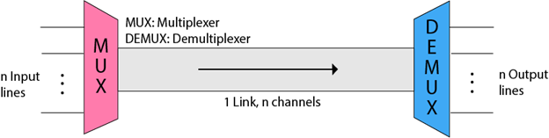

Demultiplexing is achieved by using a device called Demultiplexer (DEMUX) available at the receiving end. DEMUX separates a signal into its component signals (one input and n outputs). Therefore, we can say that demultiplexing follows the one-to-many approach.

**Multiplexing Techniques**

Multiplexing techniques can be classified as:

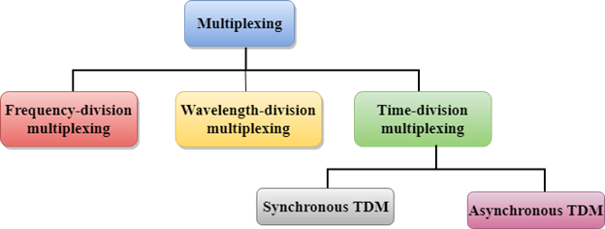

**Channelization:**

In this, the available bandwidth of the link is shared in time, frequency and code to multiple stations to access channel simultaneously.

**Frequency Division Multiple Access (FDMA)** – The available bandwidth is divided into equal bands so that each station can be allocated its own band. Guard bands are also added so that no to bands overlap to avoid crosstalk and noise.

**Time Division Multiple Access (TDMA)** – In this, the bandwidth is shared between multiple stations. To avoid collision time is divided into slots and stations are allotted these slots to transmit data. However there is a overhead of synchronization as each station needs to know its time slot. This is resolved by adding synchronization bits to each slot. Another issue with TDMA is propagation delay which is resolved by addition of guard bands.

**Code Division Multiple Access (CDMA)** – One channel carries all transmissions simultaneously. There is neither division of bandwidth nor division of time. For example, if there are many people in a room all speaking at the same time, then also perfect reception of data is possible if only two person speak the same language. Similarly data from different stations can be transmitted simultaneously in different code languages.

**Accsess Techniques:-**

**Carrier Sense Multiple Access (CSMA)**

This method was developed to decrease the chances of collisions when two or more stations start sending their signals over the datalink layer. Carrier Sense multiple access requires that each station first check the state of the medium before sending.

**Carrier Sense Multiple Access with Collision Avoidance (CSMA/CA) –**

CSMA/CA stands for Carrier Sense Multiple Access/ Collision Avoidance. It is a network protocol for transmission. It operates in the Medium Access Control Layer. This protocol is effective before the collision.

**Carrier Sense Multiple Access with Collision Detection (CSMA/*CD*) –**

CSMA/CD stands for Carrier Sense Multiple Access/ Collision Detection. It is also a network protocol for transmission and operates in the Medium Access Control Layer. In this protocol, each station senses the collision by broadcast sensing. In case of collision, the transmission is stopped and they send a jam signal and then wait for a random time context before retransmission.

In this method, a station monitors the medium after it sends a frame to see if the transmission was successful. If successful, the station is finished, if not, the frame is sent again.

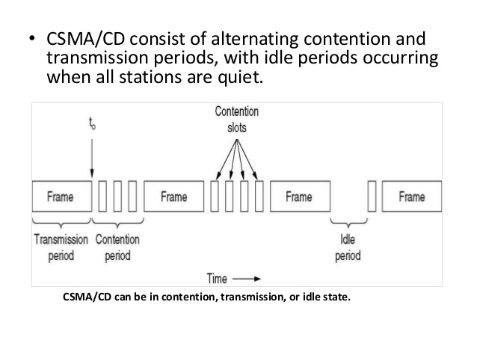

**The following are some of the important differences between CSMA/CA and CSMA/CD.**

Sr. No.

1 Effectiveness

CSMA/CA is effective before a collision.

CSMA/CD is effective after a collision.

2 Network Type

CSMA/CA is generally used in wireless networks.

CSMA/CD is generally used in wired networks.

3 Recovery Time

CSMA/CA minimizes the risk of collision.

CSMA/CD reduces recovery time.

4 Conflict Management

CSMA/CA initially transmits the intent to send the data, once an acknowledgment is received, the sender sends the data.

CSMA/CD resends the data frame in case a conflict occurs during transmission.

5 IEEE Standards

CSMA/CA is part of the IEEE 802.11 standard.

CSMA/CD is part of the IEEE 802.3 standard.

6 Efficiency

CSMA/CA is similar in efficiency as CSMA.

CSMA/CD is more efficient than CSMA.

**Wireless Networks-**

Computer networks that are not connected by cables are called wireless networks. They generally use radio waves for communication between the network nodes. They allow devices to be connected to the network while roaming around within the network coverage.

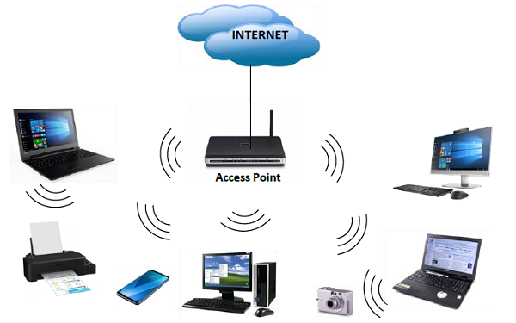

**Types of Wireless Networks**

Wireless LANs − Connects two or more network devices using wireless distribution techniques.

Wireless MANs − Connects two or more wireless LANs spreading over a metropolitan area.

Wireless WANs − Connects large areas comprising LANs, MANs and personal networks.

**Advantages of Wireless Networks**

1. It provides clutter-free desks due to the absence of wires and cables.

2. It increases the mobility of network devices connected to the system since the devices need not be connected to each other.

3. Accessing network devices from any location within the network coverage or Wi-Fi hotspot becomes convenient since laying out cables is not needed.

4. Installation and setup of wireless networks are easier.

5. New devices can be easily connected to the existing setup since they needn’t be wired to the present equipment. Also, the number of equipment that can be added or removed to the system can vary considerably since they are not limited by the cable capacity. This makes wireless networks very scalable.

6. Wireless networks require very limited or no wires. Thus, it reduces the equipment and setup costs.

**Examples of wireless networks**

Mobile phone networks

Wireless sensor networks

Satellite communication networks

Terrestrial microwave networks

**What is VoIP (Voice over Internet Protocol)technology?**

The simplest way to think about Voice over IP technology is that it is technology that has moved telephone calls away from private carriers to the same Internet your computers use. There are many advantages to this move, which are provided by the data networking protocols incorporated into VoIP technology.

For instance, a great deal of speed and reliability is added to making calls, costs are lower because signals don’t travel over a private phone line, and you have more control over your phone calls. With bare-bones VoIP technology, you have everything that’s required to send and receive messages from anyone. Yet, businesses enjoy the inclusion of some features besides the simple sending and receiving of calls, and that’s where Unified Communications comes in.

**MCQ-**

Moving signals from one line to another is called:

a. time switching

**b**. space switching

c. line switching

d. cross-point switching.

CDMA:

a. cannot be used with frequency-hopping spread-spectrum

b. cannot be used with direct-sequence spread-spectrum

c. cannot be used on an RF channel

**d**. allows many transmitters to use a band simultaneously

Optical transmission mainly uses

A WDM

B FDM

C TDM

D CDM

Which of the following is necessary to use for separating channels in FDM ?

A time slots

**B** band pass filters

C differentiation

D none of these

For separate channels in TDM, it is necessary to use

**A** time slots

B bandpass filters

C differentiation

D none of the above

When useful bandwidth of medium exceeds the required bandwidth of signals to be transmitted we use

**A** frequency division multiplexing

B time division multiplexing

C code division multiplexing

D none of the above

The sharing of a medium and its link by two or more devices is called _________

a) Fully duplexing

**b)** Multiplexing

c) Micropleixng

d) Duplexing

In _______, collisions are avoided through the use of three strategies: the interframe space, the contention window, and acknowledgments.

A) CSMA/CD

**B)** CSMA/CA

C) either (a) or (b)

D) both (a) and (b)

The AM radio band is an example of ____________________-division multiplexing. FDM

Switching signals from one line to another is called _______ switching. SPACE